**Description:** Small amounts of different salts are burned in the flame of a Bunsen burner. When the electrons in the atom reach an excited state, they must release that energy as a characteristic color, which is associated with each metallic ion will be observed and used to identify an unknown salt mixture.

**Purpose**

To observe the excitement of electrons within different metals and determine the identity of an unknown element based on previous observations

**Materials:**

|  |  |
| --- | --- |
| Barium Chloride | Potassium Chloride |
| Calcium Chloride | Sodium Chloride |
| Copper (II) Chloride | Strontium Chloride |
| Lithium Chloride | Unknown |

**Safety:** As with all labs with dangerous chemicals, closed toed shoes and hair ties are required for this lab. Do not touch any of the solid chemicals. Copper (II) Chloride and Barium Chloride are highly toxic by ingestion; avoid contact with eyes, skin and mucous membranes. Lithium Chloride is moderately toxic by ingestion and is a body tissue irritant.

**Procedure:**

* Dip the Wooden splint into the water
* Use this wet wooden splint to pick up VERY LITTLE salt.
* Hold the salt in the OUTER CONE OF THE flame and burn to show color.
* Do the same for all salts, moving from station until you have tested each salt. Also be careful **not to drop any salt onto the Bunsen burner**.

**Clean-up:** Dispose of unusable wooden splints. Clean off any salt that might have dropped onto the Bunsen burner or the lab table.

Data Table: In class tomorrow, you will fill in the name of the Ionic Salts and the symbol and charge of the metal part of the compound written as an ION (**there should be 14 rows, after your title row**). You may set up the data table “skeleton” before class.

Use every descriptive colors when observing the flames (not just “red”)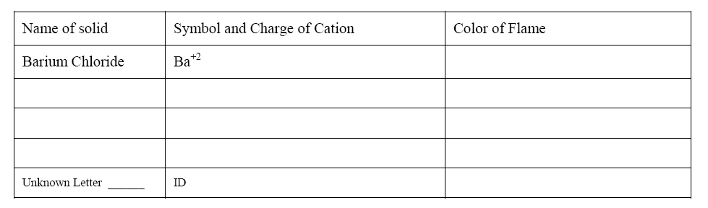.

Post Lab Questions:

1. In your own words, explain why different elements give off different colors when heated.
2. Do you think using solely this method would be an effective way to identify elements? Why or why not?
3. An electron moves from n=4 to n=3, was energy absorbed or released? How do you know?
4. What other uses do you think these chemicals could have?
5. The wavelength of green light, similar to the copper (II) chloride in lab, is 510 nm. What is the energy of a single photon of that light?